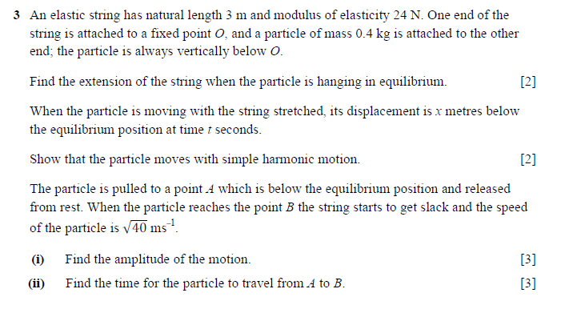

(June11IntakeTrial Paper)